**Test for time fixed effects:** P-value associated with f-statistic was less than 0.05. Therefore, I cannot reject the null hypothesis that the estimated coefficients of the year dummy variables are jointly equal to zero. Hence, I do not include time fixed effects in the model.

**Diagnostic test for Heteroskedasticity:**

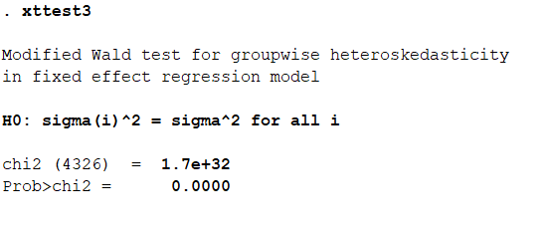

Since the p-value is less than 0.05, the null hypothesis of homoskedasticity is rejected and hence it can be concluded that there is heteroskedasticity problems in our model.

**Diagnostic test for Autocorrelation:**

The diagnostic test cannot be run. I assume that the reason is the lack of time-series data for every individual in the dataset.

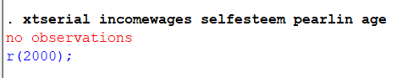

**A heteroskedasticity robust fixed effects model**

The model that is used eventually makes the standard errors robust to heteroskedasticity. The model results are shown below:

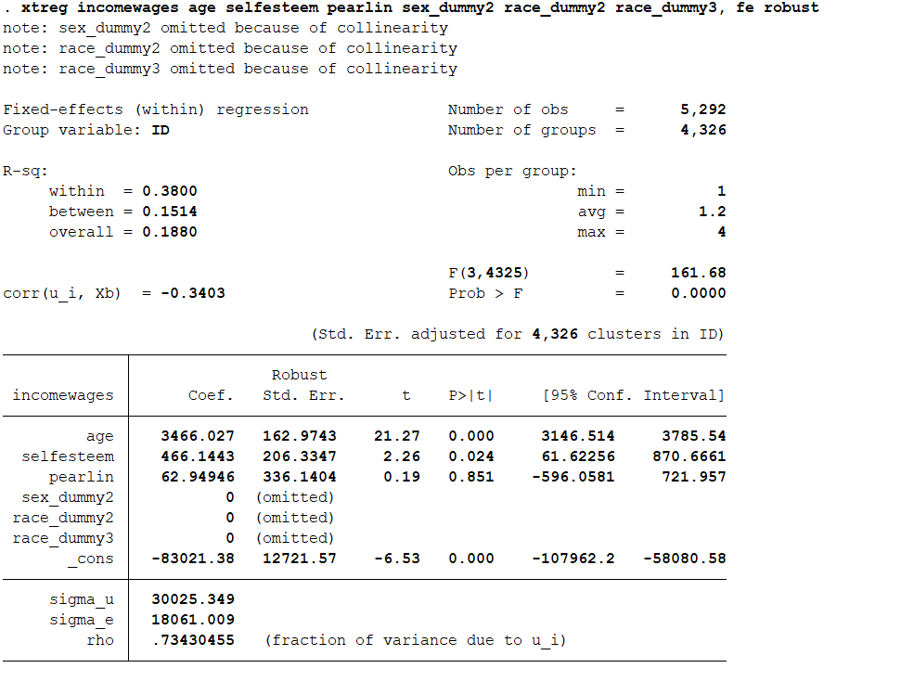

**The model equation:**

